**Electromagnetic Field Simulation of the HELIMAK Device**

Hanyang LYU1, Xiang TANG1, Rafael MACIAN-JUAN2, Xiang WANG1*

# 1College of Nuclear Science and Technology, Harbin Engineering University, 150001 Harbin, China

2*Chair of Nuclear Technology, Technical University Munich, 85748 Munich, Germany*

*\*Xiang WANG: xiang.wang@hrbeu.edu.cn*

Abstract – *The article studies the basic engineering principles of the HELIMAK device in the aspect of electromagnetics. The article establishes a model for the electromagnetic field generation and heat transfer process in the HELIMAK device and gives a corresponding explanation for the establishment of the model. The result gives the distribution of temperature and magnetic flux density on both axial and radial direction. Using this model, the article made a sensitivity analysis on parameters of the number of coils turns and the excitation current. The result shows that the coil that excites the circumferential magnetic field has more influence on the device than the coil that excites the axial magnetic field.*

I. introduction

The HELIMAK is a kind of delicate device that helps to understand the turbulence of the plasma flow. It was engineered and fabricated by the Institute of Plasma Physics of the Chinese Academy of Sciences with Shanghai Boiler Works, installed and operated by the University of Texas.1

In the device, there is a system that includes toroidal and vertical coils to create a helical magnetic field in the vacuum vessel, which could limit the flow of the plasma inside. The electron cyclotron resonance (ECR) is utilized to heat the plasma. Therefore, the device will eventually meet the stable magneto-hydrodynamic equilibrium. The whole device uses the waveguide opened inside to introduce microwaves. The excitation of the microwave is the use of 2.45 GHz heating which is common in commercial use.2

The coils used to create the magnetic field can generate considerable heat, which happens to be one of the main factors that limits the device to run for a long period of time2. Therefore, the research on the coils and their heat transfer condition are of great significance to optimize the entire device and gives the engineering reference to build such devices like the HELIMAK in the future.

II. BASIC PARAMETERS OF THE MODEL

The HELIMAK has a toroidal symmetry like in the other Tokamak device, which is made of a toroidal vacuum vessel, surrounded by 16 toroidal field coils (TF coil) with 28 turns for each coil, as well as 3 vertical field coils (VF coil) which consists of 126 turns in the top and bottom coils and 75 turns in the center coil. 2 There are also some other related supporting parts, which make minor influence on the physics simulation we discuss in the paper, therefore, been neglected.

The main height of the device is 2 m, with outer radius being 1.6 m and the inner radius being 0.6 m in the cylindrical vacuum chamber. The vacuum chamber is made of 304 stainless steel and is full of argon gas or plasma in the working condition. Both TF coil and VF coil are made of copper, which are excited by the external power supply. The entire model is shown geometrically in Fig. 1. The basic parameters are shown in TABLE I. 1

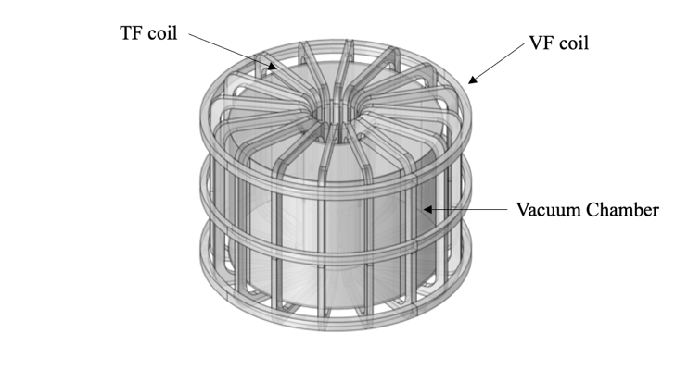

Fig. 1. The HELIMAK device

TABLE I

Parameters of the HELIMAK Device

|  |  |
| --- | --- |
| Parameters | Values |
| Major radius | 1.1 m |
| Toroidal field | 0.1 T |
| Number of TF coil | 16 |
| Number of VF coil | 3 |
| Inner radius of VC | 0.6 m |
| Outer radius of VC | 1.6 m |
| Height of VC | 2 m |
| Operating current of TF | 1.26 kA |
| Operating current of VF | 250 kA |
| Number of turns of TF | $$28×16$$ |
| Number of turns of VF | $$\left(18×7\right)×2+\left(15×5\right)$$ |

III. ESTABLISHMENT OF THE MODEL

The entire model is built with the software COMSOL Multiphysics® 3(Fig. 1). The model uses the magnetic fields interface of the AC/DC module to simulate the magnetic field and the laminar flow, heat transfer interfaces to simulate the heat transfer and the natural convection process. The main idea to simulate is that the coils create the magnetic field and generate the heat, that leads to a conduction from the inside of the coils to the outside of the coils. In the following process, heat convection between the surface of the coil and the air takes over, which eventually causes the natural convection. The heat is eventually carried out by the gas moving to the surface of the system, whose surface has been set as a boundary condition of 293.15 K. Therefore, to better simulate, an air domain with the volume of $6×6×6$ m is added into the model as shown in Fig. 2.

The operating logic of COMSOL Multiphysics® is to first establish the geometric model of the system. Secondly, different materials are given to each part of the model. Then set the boundary conditions of the model. Since COMSOL Multiphysics® is a finite element analysis software, the entire system needs to be meshed afterwards. In the end, different solvers are used to solve the entire model. And this final process is called "study".

Fig. 2. The model of the simulation scenario

*III.A. Establishment of the Magnetic Field*

Using the data shown in the last section, in “magnetic fields interface” of the AC/DC module, the current is set to excite the coils. The thing that needs to be noticed is that the conductor model should be set as “homogenized multi-turn” and the “numeric” as the coil type. At last, there should be an extra “coil geometry analysis” in the “study” process to calculate the whole magnetic field.

*III.B. Establishment of the Heat Transfer*

The establishment of the process of heat transfer uses “the heat transfer in solids and fluids interface” and “the laminar flow interface”. Besides, in the Multiphysics branch, non-isothermal flow is used to couple these two interfaces. That gives the system to simulate the natural convection process in the air domain.

Heat source is based on “the electromagnetic heating” from the multiphysics branch.

*III.C. Mesh and Study*

The system involves multiple interfaces, each system has different requirements. The calculation of the coils requires higher precision to meet the convergence of the model, therefore, a finer grid is used to describe the coil domain (Fig. 3~5). The air domain is at the opposite position. Due to the settings of the laminar flow interface and the heat convection process between the surface of the coils and the air domain, the “boundary layers” needs to add on the air side of the surface.



Fig. 3. The axial grid cell size (the blue color domain shows that the grids are smaller than the red color domain)

Fig. 4. The axial element mass (volume verses circumscribed circle radius)

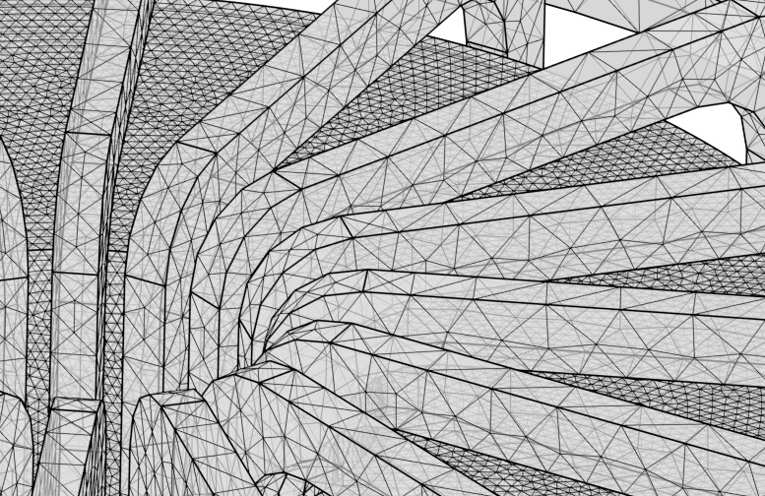

Fig. 5. The actual mesh detail

“Parametric sweep” is used in study to conduct the sensitivity analysis. Here are the three steps of the settings of the solvers.

As mentioned in section *III.A.,* in the software COMSOL Multiphysics®, a procedure in study called “coil geometry analysis” should be utilized to analyze the geometry of the coil because of the setting of “homogenized multi-turn” in AC/DC module. If not, it would eventually lead to the failure of the whole model.

“Stationary” is in study step 2. In COMSOL Multiphysics®, there are two basic solvers called “stationary” and “time dependent”. “Stationary” is to solve the circumstances that the physical quantity does not change with time. “Time dependent” is to solve the ones that do change over time. Because, in this model, the magnetic field barely changes over time or just a little change which can be totally neglected. It is reasonable to set a “stationary” study here to solve the AC/DC module.

At last, “time dependent” is used in last study, in order to solve the condition of the heat transfer changes over time. The time in the simulation stops at 45 s as the device operates in a steady state with stationary conditions for tens of seconds in the reality.4

IV. RESULTS

The simulation gives satisfied results compared with the experimental results of the real HELIMAK device and simulation models from other researchers.

图标

Fig. 6. The axial magnetic flux density of the model

Fig. 7. The radial magnetic flux density of the model

屏幕上有字

Fig. 8. The radial temperature distribution of the model

屏幕上有字

Fig. 9. The radial temperature distribution of the model at $z=1 m$ (the average height of the central VF coil)

电脑游戏的屏幕

Fig. 10. The radial temperature distribution of the model at $z=2.05 m$ (the average height of the top VF coil)



Fig. 11. The distribution of the magnetic flux density differs from $r$ and $z$. The x axis represents the arc length, and the y axis represents the magnetic flux density.



Fig. 12. The distribution of temperature differs from $r$ and $z$, $z$ is from -2 m to 4 m. The x axis represents the $z$ length begun from the bottom to the top of the whole system, and the y axis represents the temperature.

In Fig. 11 and 12, it demonstrates the distribution of the magnetic flux density and temperature along one-dimensional circles set. The magnetic flux density shows periodic change because of the distribution of the TF coils, which means the position that is nearer to the TF coils has higher flux density. Besides, inside the vacuum chamber, when the $r$ is smaller, the magnetic flux density would be higher. This also matches that the magnetic flux density is higher at the inner side of the vacuum chamber. As for the magnetic flux density varies in $z$ direction, the closer to the middle of the vacuum chamber, the smaller the periodic fluctuation of the magnetic flux density will be. That is because closer to the middle of the vacuum chamber will be farther away from the TF coil, which brings less fluctuation. The distribution of temperature differs from $r$ and $z$ shows the situation in the center of the system, through the vacuum chamber and outside the device. It vividly shows the heat generation of different parts and the heat transfer condition at the time of 45 s

Wenge Chen & Songtao Wu also used ANSYS® to simulate the electromagnetic field distribution.5 The results presented are consistent. As for our model, inside the vacuum chamber, the average value of the magnetic flux density is 0.1039 T, the highest value of the magnetic flux density is 0.1911 T and the lowest is 0.0595 T.

The initial temperature is 293.15 K which is universal for the entire system. The temperature distribution takes the data set when the time is 45 s and 52.5 s. It is very clear to recognize the process of natural convection. For the whole domain, the highest temperature is 358.08 K and the average temperature is 300.22 K. The average rate of increase of the highest temperature in the system is 1.443 K/s. Although in the reality, the HELIMAK device could operate constantly, such increasing rate is the main factor that limits its operating. And the lack of a water-cooling system could be a flaw to the device.2

The sensitivity analysis considers 4 different parameters (TABLE II).

TABLE II

Parameters Used in Parametric Sweep

|  |  |  |
| --- | --- | --- |
| Parameters | Symbol | Values |
| Operating current of TF | $I_{1}$ (A) | 1220 1240 1260 1280 1300 |
| Operating current of VF | $I_{2}$ (A) | 240 245 250 255 260 |
| Number of turns of TF | $$n_{1}$$ | 18 23 28 33 38 |
| Number of turns of VF | $$n_{2}$$ | 106 116 126 136 146 |



Fig. 13. The temperature change varies the exciting current of the turns of the TF coil in the TF coil domain, t=52.5 s

As shown in Fig. 13, the temperature changes quite significantly with the current. Due to the existence of Joule heat, the conclusions drawn by the simulation are easy to understand. In the following text, we will compare the degree of significance between this $I_{1}$ and $I_{2}$. At the same time, the lowest temperature in TF coils at 1220 is much lower blow the trend, the reason why it appears so may be the value divergence at the boundary. Fig. 14 also shows a good tendency between the magnetic flux density and the current in TF coils.



Fig. 14. The magnetic flux density change varies the exciting current of the turns of the TF coil in the TF coil domain, t=52.5 s



Fig. 15. The temperature change varies the exciting current of the turns of the VF coil in the VF coil domain, t=52.5 s



Fig. 16. The magnetic flux density change varies the exciting current of the turns of the VF coil in the VF coil domain, t=52.5 s

Comparing Fig. 13~16, the data change more drastically with the parameter $I_{1}$ rather than the other. The movement of the plasma in the vacuum chamber is more dependent on the magnetic field formed by the TF coil. This causes the number of TF coils and the current to be both greater than that of the VF coil, so the entire device is more sensitive to the changes in the current magnitude of the TF coil.

As for the sensitivity analysis of the number of the electromagnetic turns, the simulation of the electromagnetic field distribution of the system is consistent in different parameters. It allows to make corresponding improvements to the HELIMAK device in engineering.

As for the sensitivity analysis of the parameter $n_{2}$. Here, the article focuses on the difference on the domain where the data are set. The average, the highest and the lowest temperatures are all at the same level which don’t change much when the data are dealing with the entire domain. The results are shown in Fig 17. The lines maintain flat.



Fig. 17. The temperature change varies the number of the turns of the VF coil in the entire domain, t=45 s

If data source is from the VF coil domain, the result shows a different kind of perspective. After the previous expression, since the heat released by the TF coil is greater than the heat generated by the VF coil, in Fig. 17, for the temperature of the entire domain, it mainly depends on the TF coil. But for the entire VF coil domain, it is clear to find that the relevant parameters of the VF coil will have a greater impact at this domain. This is also the reason that the average and the highest temperature in VF coil domain is lower than the entire domain in the whole system. This could give the reference whether the engineers want to improve the performance of the VF coils. Besides, this also proves that the view that the TF coil has more influence than the VF coil for the whole system.



Fig. 18. The temperature change varies the number of the turns of the VF coil in VF coils domain, t=45 s



Fig. 19. The magnetic flux density change varies the number of the turns of the VF coil in vacuum chamber domain, t=45 s

As for the parameter $n_{1}$, here, the article just focuses on the temperature change varies the number of the turns of the TF coil in TF coils domain (Fig. 20) and the magnetic flux density change varies the number of the turns of the TF coil in vacuum chamber (Fig. 21).



Fig. 20. The temperature change varies the number of the turns of the TF coil in TF coils domain, t=45 s



Fig. 21. The magnetic flux density change varies the number of the turns of the TF coil in vacuum chamber domain, t=45 s

It is very clear to see that, comparing with Fig. 18~19 and Fig. 20~21, the relating parameters shows higher relevance with $n_{1}$, which is the turns of the TF coil. It is easy to find that due to the higher excitation current to the TF coils and more coils on TF than VF, the simulation results accord with the reality. In the device, it is required that the circumferential magnetic field would be much larger than the axial magnetic field, which is excited by TF coil and VF coil. Besides, it shows the reference that a more economic improvement on the device is the choosing of the improvement on the TF coil rather than the VF coil.

V. CONCLUSIONS

Because the simulation considered basically all the main factors that have influence on the heat transfer and the magnetic field. The simulation of the whole system gives a good result which could be useful when it comes to the engineering design and analysis. However, considering the outside of the air domain as an isothermal environment may have a certain impact on the heat transfer results of the entire system. The heating rate of the whole system may be different from the real situation, which is one of the main reasons that limits the device runs for a continuous period. At the same time, since the two modules of plasma and microwave were not added in the modeling process, the impact of these two modules on the entire system was ignored, which may also lead to a certain discrepancy between the simulation results and the real situation. In the future, we will try to add these two modules for the entire system.

The sensitivity analysis of the system also gives valuable data and results, which make the basic attributes of the entire system clearer. This allows us to have a deeper understanding of the physical and engineering properties of the device. At the same time, it gives a guiding reference for the construction and research of similar devices.

In sensitivity analysis, since there are just a few physical fields considered, there are not many parameters that can be selected for sensitivity analysis. This creates a certain obstacle to the understanding of the entire device.

References

1. S. T. Wu, X. Q. Mao, S. J. Du et al, “Engineering design of the HELIMAK device”, *Fusion Engineering and Design,* 63, 59~64 (2002).
2. Kenneth W. Gentle, He Huang, “Taxes HELIMAK”, *Plasma Science and Technology,* 10, 284 (2008).
3. COMSOL Multiphysics® v. 5.5. cn.comsol.com. COMSOL AB, Stockholm, Sweden.
4. Perez, Jean & Horton, Wendell & Gentle, K. & Rowan, William & Lee, Kevin & Dahlburg, Russell. “Drift wave instability in the HELIMAK experiment”, *Physics of Plasmas*, 13. 032101-032101. 10.1063/1.2168401. (2006).
5. Wenge Chen, Songtao Wu, “The influence of magnetic permeability on the configuration of magnetic field in HELIMAK device”, *Plasma Science & Technology*, Vol.5, No.3 (2003).